Cairo University  
Faculty of Computers and Artificial Intelligence

|  |  |
| --- | --- |
| **Name:** | Mina Maged Faris |
| **ID:** | 20210420 |

**Airline Reservation System**

**Domain Analysis:**

# **list of possible methods/resources/people:**

* [predictiveanalyticstoday](https://www.predictiveanalyticstoday.com/top-airline-reservation-system/)
* [wikipedia](https://ar.wikipedia.org/wiki/%D9%86%D8%B8%D8%A7%D9%85_%D8%AD%D8%AC%D8%B2_%D8%A7%D9%84%D8%AE%D8%B7%D9%88%D8%B7_%D8%A7%D9%84%D8%AC%D9%88%D9%8A%D8%A9)
* [slideserve](https://www.slideserve.com/Antony/presentation_90721)
* [academia](https://www.academia.edu/6521426/REQUIREMENTS_Analysis_Documentation_for_Air_ticket_reservation_system_ATRS_Team_Composition_Project_Title_Air_ticket_reservation_system_Prepared_By_S_No)
* [bcdtrave](https://www.bcdtravel.com/travel-tools/travel-terms-definitions-acronyms/) (Note: in this site I found my glossary)
* [slideshare](https://www.slideshare.net/SanjanaAgarwal13/airline-reservation-report)
* [projectsinventory](https://projectsinventory.com/airline-reservation-system-functional-and-non-functional-requirements/)
* [yumpu](https://www.yumpu.com/en/document/read/6467488/seg-2100-software-design-ii)

# **Introduction:**

This document describes background information that has been gathered about Airline Reservation System of Ootumlia Airlines and how it works. This information is to be used to guide the development of software to automate the process of how the system should works.

# **Glossary:**

* Airline Reservation System: A computerized system used to store and retrieve information about flight schedules, fares, seat availability, and other related information, used by airlines to manage their reservations.
* Passenger Name Record (PNR): A record in the airline reservation system that contains all the passenger's personal and flight-related information, such as name, flight number, seat assignment, and meal preference.
* Flight Itinerary: A detailed schedule of a passenger's journey that includes flight numbers, departure and arrival times, and connecting flight information.
* Availability: The number of seats that are available on a particular flight for booking by passengers.
* Fare: The price of a ticket for a particular flight, including any taxes and fees.
* Inventory Control: The process of managing and allocating seats on flights to ensure that they are filled efficiently and effectively.
* Seat Map: A visual representation of the seating arrangement on an aircraft, which shows the location and availability of seats.
* Check-in: The process of confirming a passenger's arrival at the airport and issuing a boarding pass.
* Boarding Pass: A document that allows a passenger to board a flight, containing information such as the flight number, seat assignment, and boarding time.
* Reservation Code: A unique alphanumeric code assigned to each passenger's reservation, used to identify and retrieve the reservation from the airline reservation system.

# **General knowledge about the domain:**

An airline reservation system is a complex computerized system used by airlines to manage their flight operations, ticket sales, and customer information. The reservation system keeps track of passengers who will be flying in specific seats on various flights. The airline reservation system allows airlines to manage their flight schedules, seat availability, and ticket sales, as well as track customer information. It is possible to add planes and tickets remove a flight or add a flight edit ticket price reserve a flight or cancel a flight.

# **Customers and users:**

# **Potential clients:**

* + Traveling Companies.
  + Airplanes.

# **Potential users**

* + Customers who interested in traveling (Passengers) they can reserve a flight or cancel the flight.
  + Airport staff: Airport staff use airline reservation systems to check in passengers, issue boarding passes, and manage the boarding process.
  + Reservation agents: Reservation agents work for airlines or travel agencies and use airline reservation systems to manage bookings, process payments, and provide customer service to passengers.
  + An Admin to add plane, set ticket price, edit ticket price, remove a flight and add a flight.

# **Tasks and procedures currently performed:**

* Making a flight
  + An admin will make a flight and set its price and set the date and time.
  + Put some additional notes.
* Reserve a flight.
  + After login Passenger can reserve a flight and buy a ticket after receiving the confirmation code.
  + A passenger can also cancel the reservation of the flight.
* Delete a flight.
  + An admin can delete a flight.

**Requirements**

# **Functional Requirements:**

|  |  |
| --- | --- |
| **Requirement ID** | **Requirement Statement** |
| FR01 | The application should have a login/sign-up screen and make a login or sign up. |
| FR02 | Create or remove a new regular flight.   * + Only admin can create a regular flight and set the destination and date.   + Only admin can remove a regular flight for any reason.   + There must be a button to create and remove |
| FR03 | Search for a particular regular flight   * + These can be used by admin and passenger to access the flight easily. |
| FR04 | Modify the attributes of a regular flight.   * + Only admin can modify a regular flight like its date or name or price. |
| FR05 | Create a specific flight.   * + Only admin can create a flight and set the destination and date.   + There must be a button to create. |
| FR06 | Cancel a specific flight.   * + Only admin can remove a flight for any reason.   + There must be a button to remove. |
| FR07 | Book a passenger on specific legs of a flight.   * + There must be a button to make the passenger book and then we must verify that book by OTD. |
| FR08 | Cancel a booking.   * + There must be a button to make the passenger cancel the booking and then we must verify that cancelation by OTD. |

# **Non-Functional Requirements:**

|  |  |
| --- | --- |
| Measure | Details |
| **Performance** | * The Sign-in/sign-up screen should take about 7 seconds to load. * Every panel in the system should take less than 10 seconds to load. * Confirmation code must be sent within 2 minutes. * Reserving or canceling a flight must take 20 seconds. * The system should be able to manage a high volume of requests and transactions with minimal delays or performance concerns. |
| **Scalability** | The system should be able to scale up or down to meet changing demand. |
| **Security** | The system should protect sensitive client data and maintain the security of all transactions like storing the RNR encrypted and storing the way that the passenger pays encrypted (credit card, PayPal account,……….). |
| **Maintainability** | The system should be simple to maintain and update, with low downtime.  The system should have a 95% chance of maintainability for 12 hours. Which means that if a component in the system had a critical issue, there is a 98% chance that this component will be fixed in 1 days because every hour costs a lot of money. |
| **Reliability and availability** | The system should be active 99% of the day.  The system should be always available, with as little downtime as possible for maintenance or updates. |
| **Usability** | The system should be simple to use for both customers and staff, with a simple and straightforward interface. |

# **Use Case Model:**

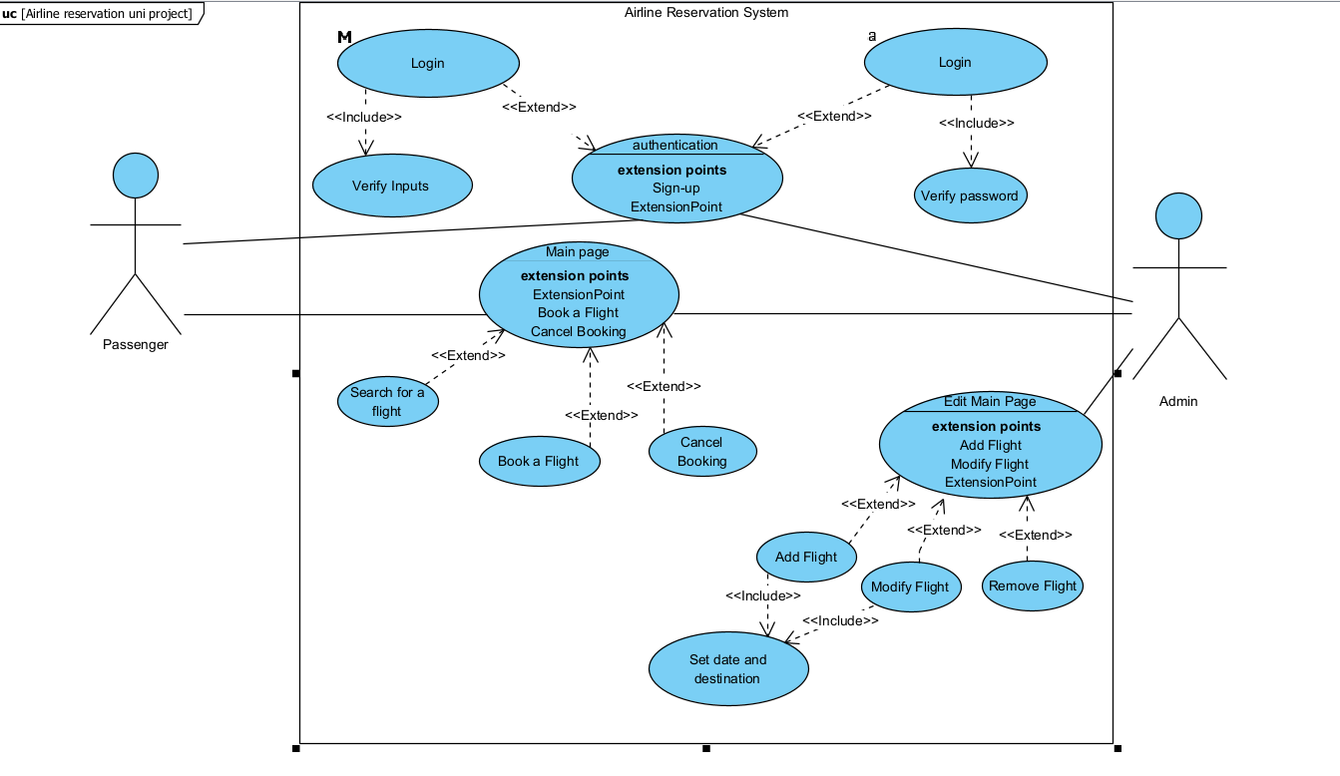

# **UML Class Diagram:**

